TC-DISP-031
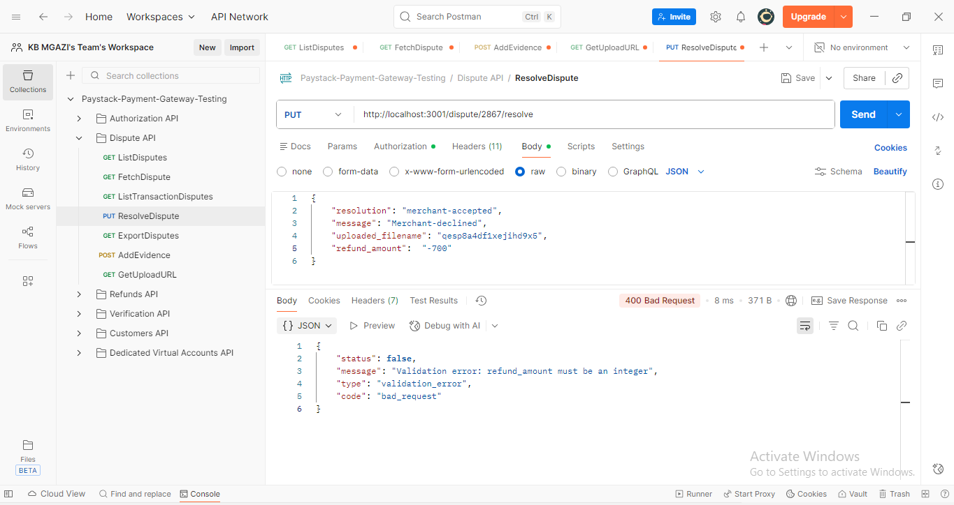
Request:
{
"resolution": "merchant-accepted",
"message": "Merchant-declined",
"uploaded_filename": "qesp8a4df1xejihd9x5",
"refund_amount": "-700"
}

Response:
{
"status": false,
"message": "Validation error: refund_amount must be an integer",
"type": "validation_error",
"code": "bad_request"
}

